CODECACHE

PROJECT DOCUMENTATION

Prepared by
MD. Shoaib Sikder
Repository: ShoaibSikder / CodeCache
https://github.com/ShoaibSikder/CodeCache
OCTOBER 24, 2026
REPOSITORY REVIEW | MAIN BRANCH

⌘ CodeCache
Project Documentation

1. EXECUTIVE SUMMARY 3
2. INTRODUCTION 3
2.1 Problem Statement 3
2.2 Project Objectives 4
2.3 System Boundaries (Scope) 4
2.4 Stakeholder Analysis 4
2.5 Admin Control Scope 5
3. SCENARIO WRITING 5
Scenario-1: User Registration / Login and Token Refresh 5
Scenario-2: Profile Viewing / Editing and Password Change 5
Scenario-3: Browse a Language and Load the Cheat-Sheet Tree 5
Scenario-4: Search Languages, Topics and Snippets 6
Scenario-5: Copy, Edit and Save a Code Snippet 6
Scenario-6: Execute Code through Judge0 6
Scenario-7: AI Code Doctor Analysis 6
Scenario-8: Generate an AI Quiz 6
Scenario-9: Complete a Quiz and Record Learning XP 6
Scenario-10: Daily Challenge and Streak Tracking 7
Scenario-11: Solve a Bug-Fix Challenge 7
Scenario-12: Create and Save Personal Language Notes 7
Scenario-13: Mark Topic Completion and Review Learning Path 7
Scenario-14: Browse Saved Content and Toggle Bookmarks 7
Scenario-15: Administrator Dashboard, User List and Analytics 7
Scenario-16: Manage Languages, Sections, Subsections and Content Items 8
4. REQUIREMENT SPECIFICATION 8
4.1 Functional Requirements (FR) 8
4.2 Non-Functional Requirements (NFR) 9
5. SYSTEM DESIGN & ARCHITECTURE 10
5.1 System Architecture Diagram 10
5.1.1 Admin Control and Monitoring Architecture 11
5.2 System Modeling 12
User Interaction Use Case Diagram 12
Admin Control Use Case Diagram 13
Activity Diagrams: Scenario-1 to Scenario-8 14

⌘ CodeCache
Project Documentation | Contents (continued)

Activity Diagrams: Scenario-9 to Scenario-16 22
5.3 Database Design 29
Core Content Hierarchy ERD 29
Learning Progress Data Model 30
Saved Content and Personal Notes Data Model 31
Analytics and Playground Data Model 32
Data Dictionary 33
Database Integrity Rules 37
6. TECHNICAL IMPLEMENTATION 37
6.1 Backend / Data Interaction Documentation 37
6.1.1 Backend Organization 37
6.1.2 RESTful API Endpoints 38
6.1.3 External Services and Media Handling 39
6.1.4 Search Implementation 39
6.1.5 Learning Progress, XP and Client Cache 40
6.1.6 Admin Control and Analytics 40
6.2 Relationship & Access Rules 40
6.3 Frontend Organization 41
6.4 Administration Frontend Organization 41
7. QUALITY ASSURANCE & TESTING 41
7.1 Test Case Scenarios 41
7.2 Requirements Traceability Matrix (RTM) 43
8. INDIVIDUAL CONTRIBUTION 43
9. CONCLUSION & FUTURE WORK 44
10. APPENDICES 45
Appendix A: Repository and Architecture Notes 45
Appendix B: Backend Setup 45
Appendix C: Frontend Setup and Deployment 45
Appendix D: Environment Variables 46
Appendix E: Administrator Setup and Responsibilities 46
Appendix F: Limitations and Verification Notes 47
Appendix G: Repository References 47

1. Executive Summary
CodeCache is an AI-assisted programming reference and learning platform designed to organize programming knowledge into searchable, language-specific cheat sheets. Its core content model is hierarchical: programming language, section, subsection, and typed content item. Learners can browse explanations and code examples, copy or locally edit snippets, run supported code through Judge0, ask the AI Code Doctor to review source code, and generate short multiple-choice quizzes through Groq.
The application also includes account registration and JWT-based authentication, saved snippets, personal language notes, topic-completion tracking, XP and streak records, simple learning challenges, analytics, and a React administrator dashboard for maintaining language and lesson content. The frontend is built with React 18, Vite and Tailwind CSS; the backend uses Django and Django REST Framework; PostgreSQL is configured through a Supabase connection string.
Main Value Proposition:
- For learners: one place to find concise programming references, inspect example code, try supported code in an online runner, and practice through quizzes and challenges.
- For content maintainers: a nested content management model enables language guides to be organized and reordered without changing React page templates for every topic.
- For the project: CodeCache combines API design, role checks, relational modeling, client caching, external-service integration, and progress tracking within one full-stack web application.
Technology Stack:
- Frontend: React 18, Vite, React Router, Axios, Tailwind CSS, Radix/shadcn-style UI components, Framer Motion, Lucide icons, Recharts and Sonner notifications.
- Backend: Python, Django 5.0-compatible dependencies, Django REST Framework, Simple JWT, custom permissions, and application modules for accounts, languages, content, search, analytics, learning and playground execution.
- Database: Supabase-hosted PostgreSQL, accessed by the active Django ORM models and migrations. A Prisma schema/client also exists in the repository and needs schema-authority reconciliation before deployment workflows are treated as interchangeable.
- External services: Groq for AI code review and quiz generation; Judge0 for remote code execution; a Supabase Storage helper for media operations whose full integration into content endpoints should be verified.
- Development and deployment: Git/GitHub, VS Code, Node.js/npm, Python/pip, Vite development/build server, and the README’s suggested Vercel frontend plus Render/Gunicorn backend arrangement.
Repository review scope: This document describes the public main-branch code and README reviewed on October 24, 2026. It is not a live production audit: external credentials, cloud configuration, migration success, and deployed endpoint behavior were not independently verified.

2. Introduction

2.1 Problem Statement
Programming learners often move between tutorials, reference pages, and separate tools to look up syntax, compare examples, and test code. The information can be difficult to navigate consistently, and practice tools are commonly detached from the reference material itself. CodeCache addresses this problem by keeping reference content in an ordered hierarchy and embedding snippet actions, AI assistance, quizzes, and learning progress in the same learning interface.

2.2 Project Objectives
- Provide a public library of programming-language guides organized into sections, subsections and typed content blocks.
- Allow users to create accounts and authenticate through access and refresh JSON Web Tokens.
- Support readable code examples with syntax highlighting, copy-to-clipboard, local code editing and external execution through Judge0.
- Offer AI-assisted source-code review and beginner-friendly quiz generation through the Groq API.
- Implement search across language, section, subsection and content text, plus lightweight suggestions.
- Give authenticated users personal saved content, language notes, topic completion, XP and streak tracking.
- Provide role-protected content CRUD and administrator analytics for platform usage and learning content.
- Separate reusable frontend components, API calls, backend apps, data models and external-service integrations for maintainability.

2.3 System Boundaries (Scope)
In-Scope:
- Public language and cheat-sheet browsing; typed lesson rendering; search and suggestions.
- Registration, login, token refresh, profile access/update, password change and logout.
- Snippet copy/edit/save, online execution through Judge0, AI code review, and AI quiz generation.
- Personal learning profile, topic completion, XP/streak events, saved items and notes.
- Protected management of languages, sections, subsections and content items; registered-user listing and analytics dashboard.
- Public tracking of page views/searches and display of popular language/section data.
Out-of-Scope or Not Verified in This Repository Snapshot:
- Real-time collaboration, private messaging, community submissions/upvotes backed by a service API, social feeds and classroom administration.
- A sandbox owned by CodeCache: execution is delegated to Judge0, so runtime availability and isolation depend on that service.
- Guaranteed persistent media upload from every content-management form to Supabase Storage; a helper exists, but standard content views do not visibly invoke it.
- Production rate limiting, a complete automated test suite, scheduled data aggregation, and a fully reconciled Prisma/Django migration strategy.

2.4 Stakeholder Analysis
Stakeholder | Needs / Responsibilities
Visitor | Explore public language guides, search topics, view snippets, use public AI/playground endpoints where configured.
Registered Learner | Use personal notes and saved items, complete topics, build XP/streak progress, and access login-protected learning screens.
Editor Role | Maintain permitted lesson structures where the relevant endpoint permits the editor role; access varies by endpoint and should be aligned with frontend guards.
Administrator | Manage languages and content, inspect the registered-user list, view analytics and maintain public reference data.
Super Administrator | Administrator capabilities plus the highest application role; Django superuser/staff capabilities also affect built-in admin access.
Developer / Maintainer | Maintain React components, Django APIs, PostgreSQL schema/migrations, service credentials, deployment settings and security boundaries.

2.5 Admin Control Scope
The custom React admin area provides an overview and content-management interface for languages, sections, subsections and content items. It also requests a registered-user list and analytics data. Backend route permissions are enforced with JWT authentication and custom role checks; the frontend route is guarded for roles named admin or super_admin. These checks are not fully consistent across all roles: for example, subsection endpoints allow editor roles through IsEditor, while the current frontend admin-route wrapper recognizes only admin and super_admin. The document therefore treats editor-facing administration as a role-alignment issue rather than assuming every editor has access to the whole admin UI.

3. Scenario Writing

Scenario-1: User Registration / Login and Token Refresh
- Entry: A visitor selects Register or Login and supplies the required account details.
- Validation: Registration validates password confirmation and Django password rules; login validates email and password.
- Success: The API returns user data plus access and refresh JWTs. The frontend stores tokens in localStorage and attaches the access token as a Bearer header.
- Recovery: A 401 response triggers one refresh attempt. If refresh fails, saved tokens are cleared and the browser is redirected to the home route.

Scenario-2: Profile Viewing / Editing and Password Change
- Access: An authenticated user requests /api/v1/auth/profile/ with a valid access token.
- Display: The API returns username, email, name, role, activity status and timestamps.
- Update: The authenticated user may PATCH permitted profile fields; read-only fields include identifier, username, email and role.
- Password: Password change verifies input through its serializer and stores the new password through Django password hashing.

Scenario-3: Browse a Language and Load the Cheat-Sheet Tree
- Trigger: A visitor opens the homepage and chooses a programming language.
- Fetch: The client requests the active language list or a language detail by slug; cached results may be shown before revalidation.
- Assembly: The backend fetches active sections, subsections and content items in display order and serializes the nested hierarchy.
- Render: The Language page builds a topic index and renders supported content types such as paragraphs, tables, notes and code snippets.

Scenario-4: Search Languages, Topics and Snippets
- Input: A user submits a query or uses search suggestions as they type.
- Validation: The full search endpoint requires a nonempty query of at least two characters.
- Processing: Case-insensitive database matching checks language names/descriptions/slugs, section titles/descriptions/slugs, subsection titles/descriptions/slugs and JSON content data.
- Result: The API returns flattened and grouped search results; the client renders links and records the query in analytics.

Scenario-5: Copy, Edit and Save a Code Snippet
- Display: A code ContentItem is passed into CodeSnippetCard with language, title, code and optional learning hints.
- Edit / Copy: The user can edit the snippet in the component and copy the current code to the clipboard.
- Save: For an authenticated user, the bookmark action toggles the relation through the saved-content API.
- Boundary: Editing is client-side for the current snippet; it does not update the shared reference content record.

Scenario-6: Execute Code through Judge0
- Input: The user selects a supported language, writes code and optionally provides standard input.
- Validation: The backend requires language and code and checks the language against a hard-coded Judge0 ID map.
- Execution: The API stores a submission record, encodes source/input as Base64, then sends the request to Judge0 with a 30-second timeout.
- Result: The backend decodes standard output and compile/runtime errors, records execution status/time/memory/token, and returns the result to the UI.

Scenario-7: AI Code Doctor Analysis
- Input: The user submits source code and a programming-language label to the public AI endpoint.
- Configuration: The backend requires GROQ_API_KEY and uses GROQ_MODEL or the configured Llama default.
- Processing: The prompt asks the model to identify bugs, explain causes, propose corrected code and provide tips/optimizations.
- Response: The result text is returned to the frontend; malformed JSON, missing configuration or provider errors are returned as API failures.

Scenario-8: Generate an AI Quiz
- Input: The quiz component submits a language and optional topic to the AI quiz endpoint.
- Generation: Groq is asked to return four beginner-friendly multiple-choice questions with four options, a correct answer index and an explanation.
- Parsing: The backend parses the JSON response and returns the questions; the frontend normalizes question data.
- Fallback: The frontend includes locally defined fallback quiz content if AI generation fails or the response cannot be normalized.

Scenario-9: Complete a Quiz and Record Learning XP
- Activity: The learner answers questions and the interface calculates a result.
- Event: A signed-in learner records a quiz activity using a deterministic action key.
- Integrity: The backend’s unique constraint on user, activity kind and action key prevents duplicate records for the same event.
- Progress: Quiz activity is configured for 75 XP; repeat submissions with the same activity key do not award additional XP.

Scenario-10: Daily Challenge and Streak Tracking
- Access: Daily Challenge presents a local language-specific prompt and expected output; the component requires login for progress recording.
- Answer: The learner submits a predicted output and receives correctness feedback.
- Record: A successful event uses the language and local date to form its action key and awards configured daily-challenge XP once.
- Streak: The backend compares the last recorded activity date to today and yesterday to update the current streak.

Scenario-11: Solve a Bug-Fix Challenge
- Display: The UI loads a locally defined broken-code example, options and explanatory answer.
- Choice: The learner selects a proposed fix and sees correct/try-again feedback.
- Progress: A correct answer submits a bug_fix activity for the chosen challenge; the backend’s activity uniqueness prevents repeat XP for the same key.
- Limit: The challenge data and solution options are local frontend data rather than a server-authored challenge catalogue.

Scenario-12: Create and Save Personal Language Notes
- Load: The client fetches the current user’s note for the selected language.
- Edit: The learner writes notes and the UI debounces the save request briefly to avoid sending every keystroke.
- Persist: A PUT request creates or updates the LanguageNote unique to the user/language pair.
- Progress: The first non-empty note creation can record a note activity and configured 15 XP.

Scenario-13: Complete a Topic and Review Learning Path
- Overview: The Learning Path fetches the learning overview and language list, then opens the last selected language or a default language.
- Completion: The learner marks a subsection complete through the authenticated completion endpoint.
- Integrity: The user/subsection pair is unique; XP is awarded only when a completion record is newly created.
- Navigation: LearningDashboard updates completed topic and progress information and can jump to the related subsection.

Scenario-14: Browse and Toggle Saved Content
- Access: The Saved Items page checks for a signed-in user and requests that user’s saved content.
- Presentation: The API returns content title, category, language, code and saved-record identifier.
- Toggle: Posting a content item ID creates a saved relation or deletes the existing relation if already saved.
- Integrity: A unique constraint stops duplicate user/content bookmarks.

Scenario-15: Administrator Dashboard, User List and Analytics
- Entry: An administrator signs in through the admin login page and the frontend checks the role before opening the dashboard.
- Fetch: The dashboard requests languages, sections, subsections, content items, registered users and analytics.
- Monitor: The analytics endpoint aggregates views and searches, compares today/yesterday, and returns popular languages/sections and recent-period statistics.
- Authorization: The analytics endpoint requires IsAuthenticated and IsAdmin; user list applies a server-side is_admin property check.

Scenario-16: Manage Learning Content
- Action: An administrator chooses a language, section, subsection or content item to create, edit or delete.
- Authorization: The API checks JWT authentication and the role permission configured for that endpoint.
- Validation: Slugs are checked for format and scoped uniqueness; content data must be a JSON object.
- Persistence: Successful mutations are saved with Django ORM and the frontend clears relevant language/search caches; errors are shown in the admin interface.

4. Requirement Specification

4.1 Functional Requirements (FR)
ID | Feature | Description | Stakeholders
FR01 | Account Registration | Create an account with username, email and password confirmation. | Visitors
FR02 | JWT Login / Logout | Authenticate by email/password, issue access/refresh tokens and blacklist refresh on logout. | Users
FR03 | Token Refresh | Refresh access token and clear invalid local credentials safely. | Users
FR04 | Profile Management | Retrieve own account details and update allowed profile fields. | Users
FR05 | Password Change | Validate and update a signed-in user password. | Users
FR06 | Language Directory | List active programming languages in display order. | All visitors
FR07 | Nested Reference Content | Serve active language → section → subsection → content-item trees. | All visitors
FR08 | Typed Content Rendering | Render paragraphs, headings, code, table, note, warning, tip, output, image and divider blocks. | Learners
FR09 | Code Snippet Actions | Show syntax-highlighted code and allow local edit/copy actions. | Learners
FR10 | Saved Content | Toggle personal saved status and retrieve current user saved content. | Users
FR11 | Topic Completion | Record completed subsections and award 20 XP for a new completion. | Users
FR12 | Learning Overview | Return XP, current streak, last language, completed topics and saved item IDs. | Users
FR13 | Learning Notes | Retrieve and save a personal note per programming language. | Users
FR14 | Learning Activities | Record daily challenge, bug fix, quiz and note events with configured XP values. | Users
FR15 | Last-Selected Language | Store the user’s last active language for Learning Path navigation. | Users
FR16 | Content Search | Search active languages, sections, subsections and JSON content items. | All visitors
FR17 | Search Suggestions | Return language/section/subsection suggestions as query text is entered. | All visitors
FR18 | Code Execution | Validate source and language; delegate execution to Judge0 and return output/status/metrics. | All visitors
FR19 | Execution Status Lookup | Retrieve a saved execution record by its Judge0 token. | All visitors
FR20 | AI Code Doctor | Submit source code for AI bug analysis, explanation, fixes and recommendations. | All visitors
FR21 | AI Quiz Generation | Generate four MCQs with options, correct index and explanation from a language/topic. | All visitors
FR22 | Page View Analytics | Record path, optional content hierarchy, referrer, IP and user-agent information. | All visitors
FR23 | Search Analytics | Record non-empty search query and result count. | All visitors
FR24 | Popular Content | Return top viewed languages and sections across the previous seven days. | All visitors
FR25 | Analytics Dashboard | Return daily trends, top content/searches and recent-period visitor/search counts. | Admins
FR26 | Language Management | Create, list, update and delete language records. | Admins
FR27 | Section Management | Create, list, update and delete sections under languages. | Admins
FR28 | Subsection Management | Manage subsection hierarchy using endpoint-specific editor/admin permissions. | Editors / Admins
FR29 | Content-Item Management | Create, list, update and delete JSON-backed lesson content items. | Admins
FR30 | Registered-User Listing | Allow an authenticated admin-role user to list user records. | Admins
FR31 | Client-Side Caching | Cache language/search GET responses in memory/session storage and revalidate stale data. | All visitors
FR32 | Responsive Learning UI | Provide route-level and component-level loading states and mobile/desktop layouts. | All visitors

4.2 Non-Functional Requirements (NFR)
Security: Protected APIs require JWT authentication where configured, role checks for management endpoints, Django password hashing, serializer validation and careful secret handling. Production deployment should disable permissive CORS and add rate limiting to public AI/code-execution endpoints.
Usability: Language content should remain scannable and hierarchical; loading skeletons, clear empty states, fallback quiz data and toast feedback should help explain system state.
Performance: Nested language content is prefetched; cached language/search responses reduce repeat network requests. Search results have configured limits and standard API pagination is available where used.
Reliability: Database uniqueness constraints protect username/email, scoped slugs, saved-item pairs, topic completions and learning activity keys. External service failures should return structured errors.
Maintainability: Feature-oriented Django apps, API service modules and reusable React components divide application responsibilities.
Compatibility: The React/Vite interface targets current browsers and adapts its topic navigation and content layout for smaller screens.
Scalability: Database query behavior, pagination, external API rate budgets, and event aggregation should be monitored before high-volume production use.
Privacy: Analytics stores IP address and user-agent information, while JWTs are currently held in browser localStorage; production data collection and token-storage risks should be reviewed and documented.
Observability: Admin analytics exposes views, searches, popular pages, and recent-period counts; production logging is configured in the production Django settings, though runtime log delivery should be validated.
Data Consistency: The Django models/migrations and the partial Prisma schema must be reconciled so there is one authoritative schema and one documented migration process.

5. System Design & Architecture

5.1 System Architecture Diagram
The component diagram shows the browser-facing React application, its Axios/JWT/cache layer, the Django REST API and the configured data/external service dependencies. Solid links indicate source paths in normal use; the Supabase Storage connection is drawn as a dashed helper dependency because standard content endpoints reviewed do not visibly route uploads through it.
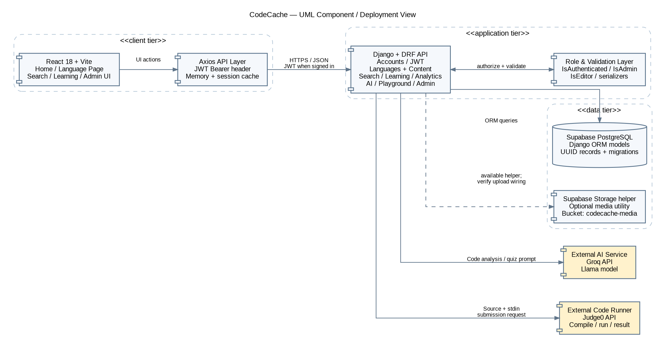
Figure 5.1: CodeCache Complete System Architecture

5.1.1 Admin Control and Monitoring Architecture
The admin frontend calls protected content and analytics endpoints. The backend evaluates the current JWT and the role-specific permission class before an operation is performed. The diagram represents the implemented boundary; it does not imply that user banning, moderation queues, or role editing are present because those workflows are not implemented in the reviewed dashboard.
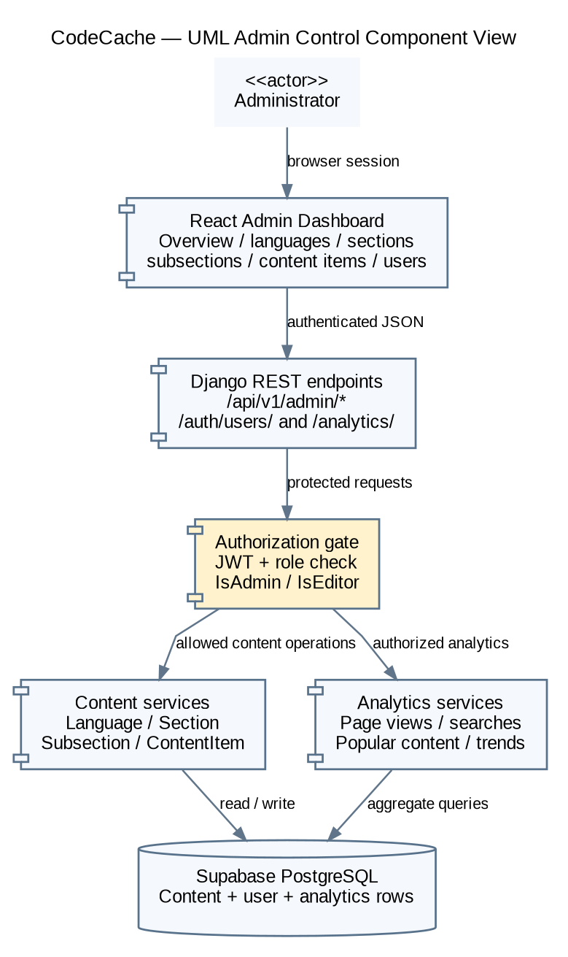
Figure 5.1.1: Admin Control and Monitoring Architecture

5.2 System Modeling

User Interaction Use Case Diagram
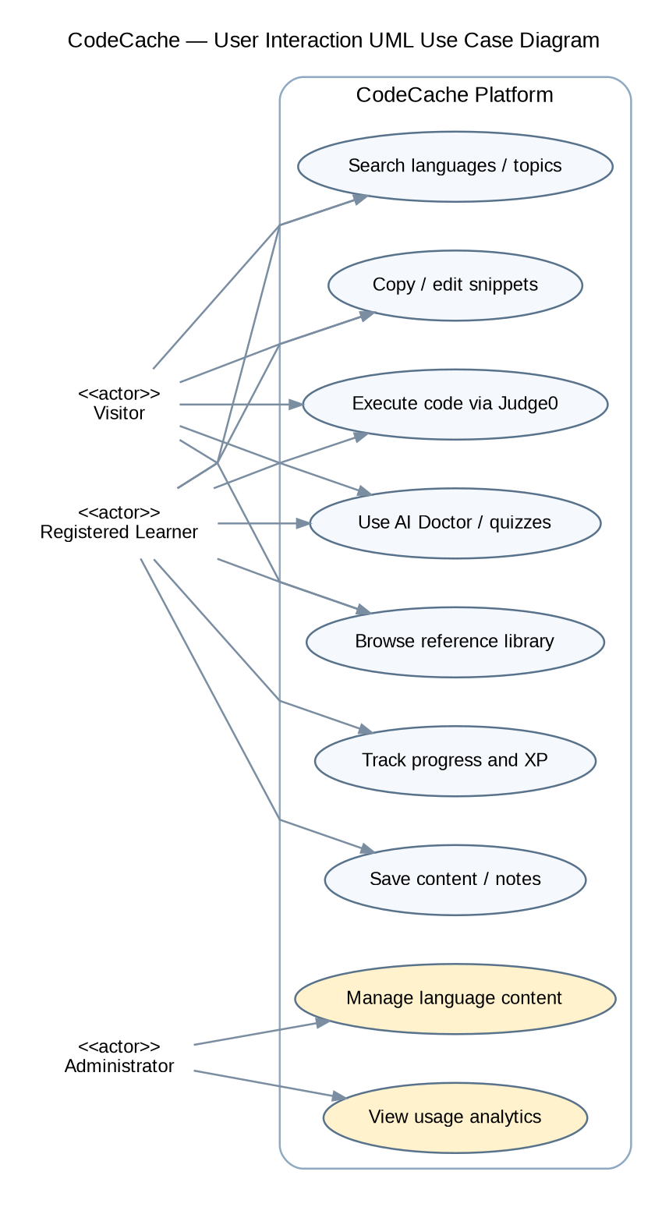
Figure 5.2: CodeCache User Interaction Use Case Diagram

Admin Control Use Case Diagram
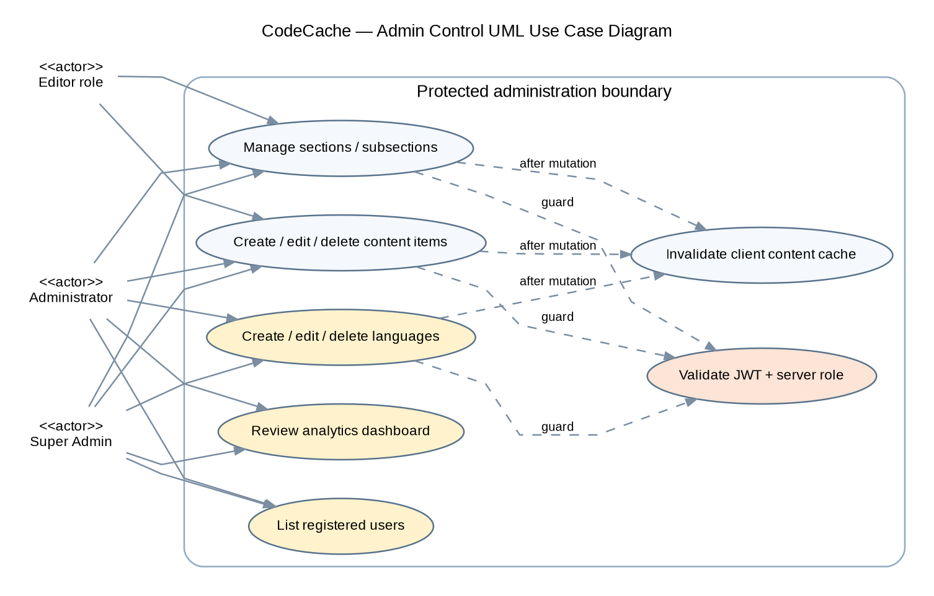
Figure 5.2.1: CodeCache Admin Control Use Case Diagram

Activity Diagrams
The activity diagrams model the principal public, learner and administrator workflows. Decision nodes describe validation, authentication or duplicate-event outcomes so both success and failure paths remain visible.

Scenario-1: User Registration / Login and Token Refresh
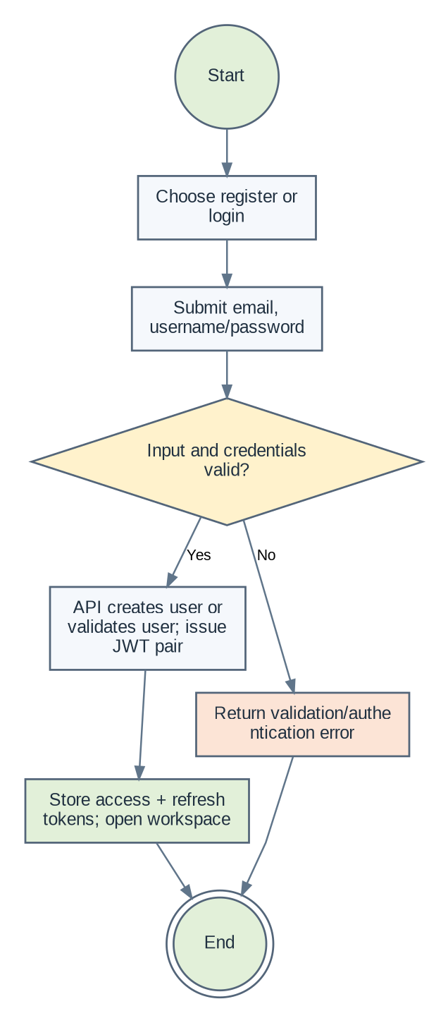
Figure 5.2.2: Scenario-1: User Registration / Login and Token Refresh

Scenario-2: Profile Viewing / Editing and Password Change
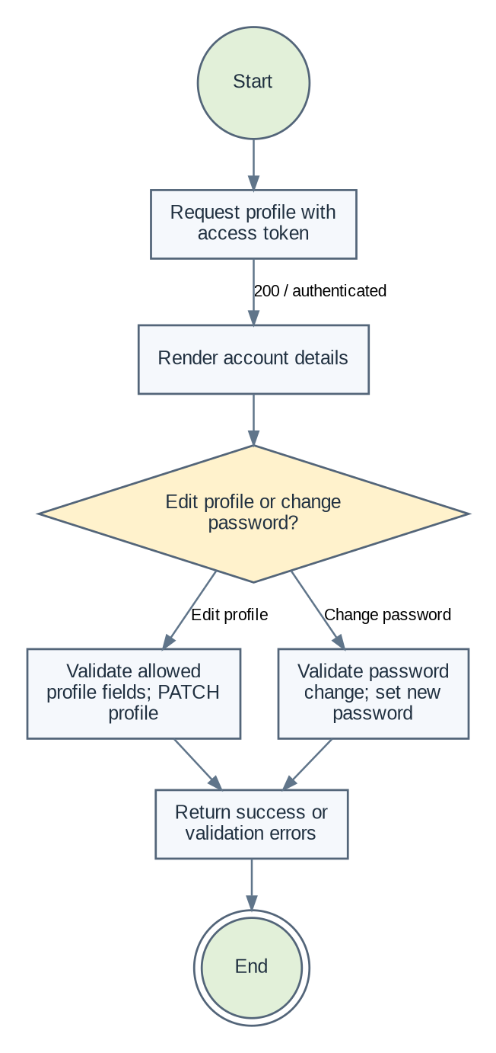
Figure 5.2.3: Scenario-2: Profile Viewing / Editing and Password Change

Scenario-3: Browse a Language and Load the Cheat-Sheet Tree
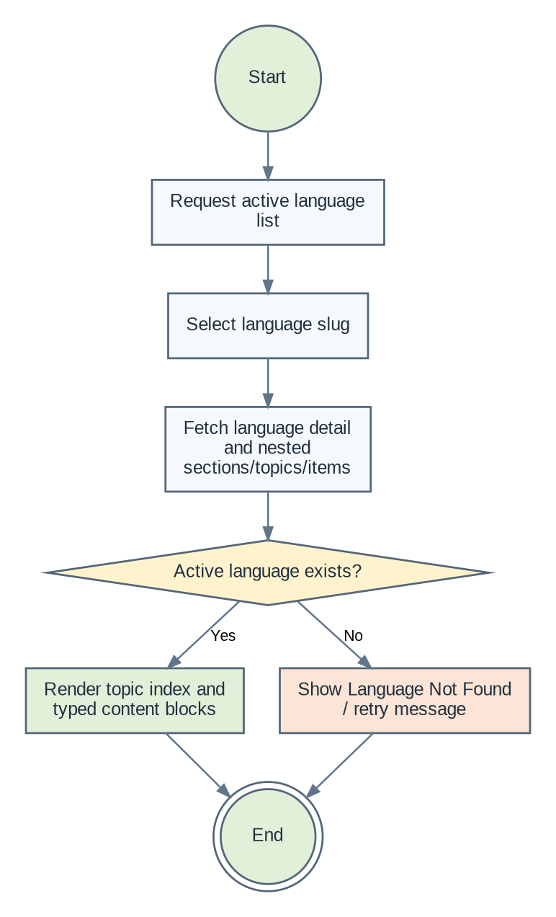
Figure 5.2.4: Scenario-3: Browse a Language and Load the Cheat-Sheet Tree

Scenario-4: Search Languages, Sections, Topics and Content
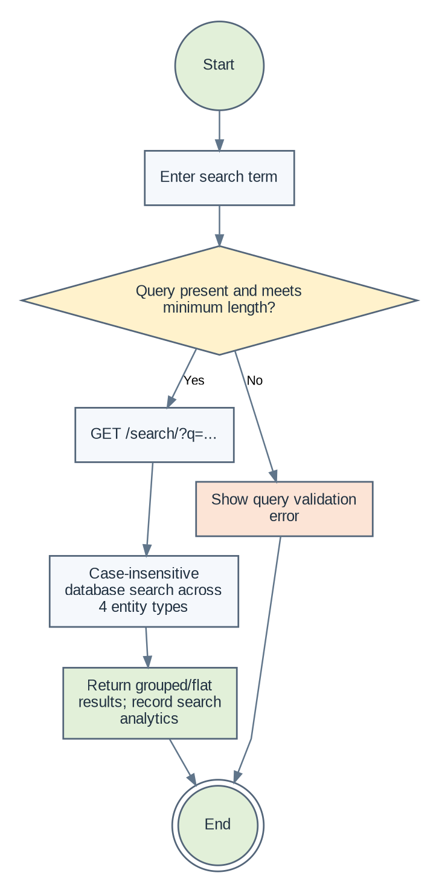
Figure 5.2.5: Scenario-4: Search Languages, Sections, Topics and Content

Scenario-5: Copy, Locally Edit and Save a Code Snippet
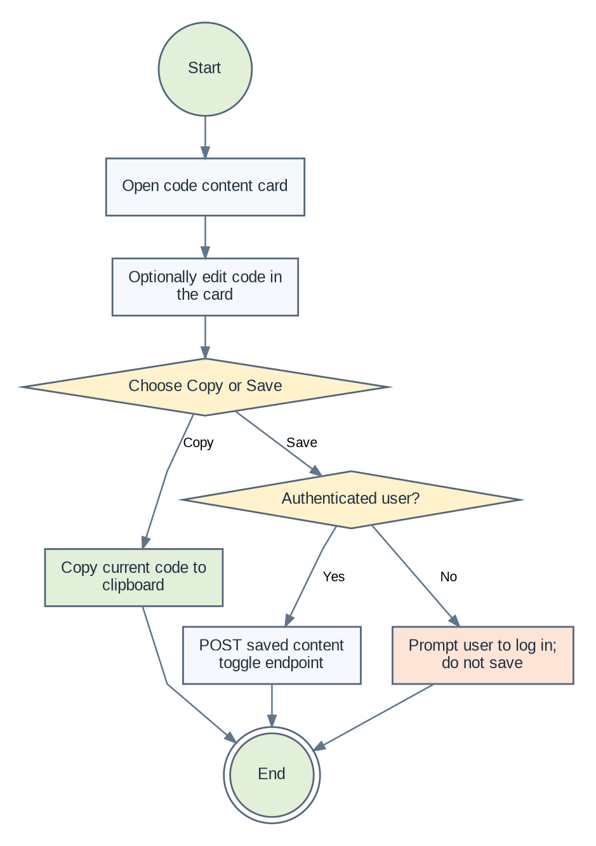
Figure 5.2.6: Scenario-5: Copy, Locally Edit and Save a Code Snippet

Scenario-6: Execute Code Through the Judge0 Playground
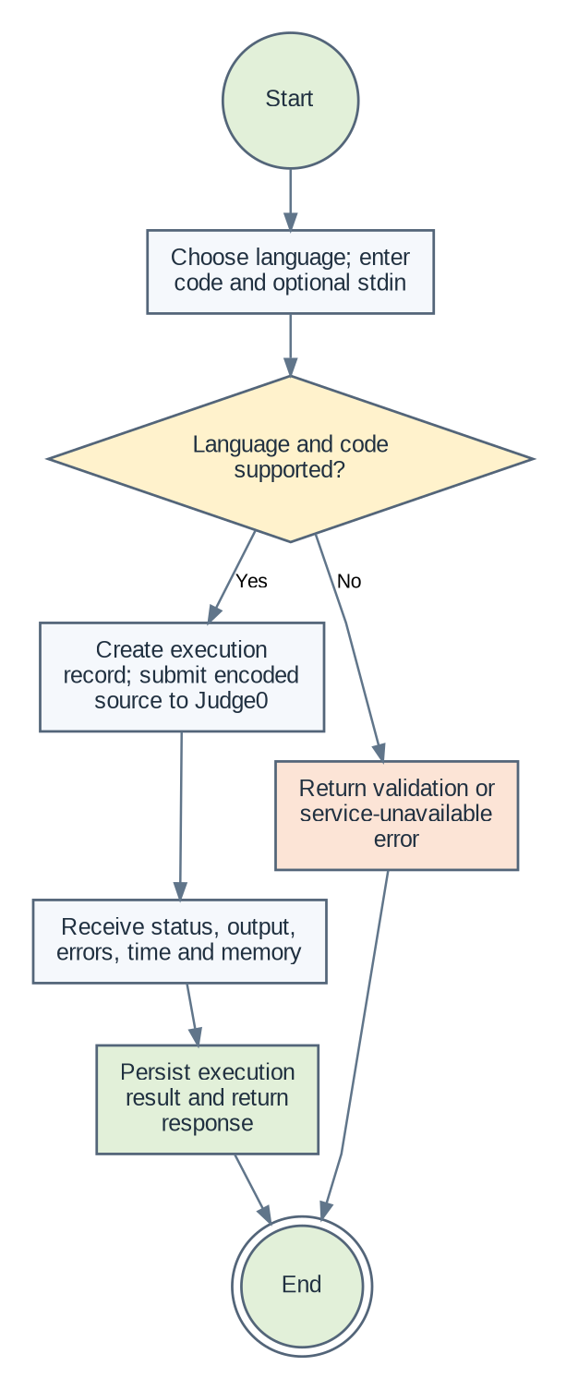
Figure 5.2.7: Scenario-6: Execute Code Through the Judge0 Playground

Scenario-7: AI Code Doctor Analysis
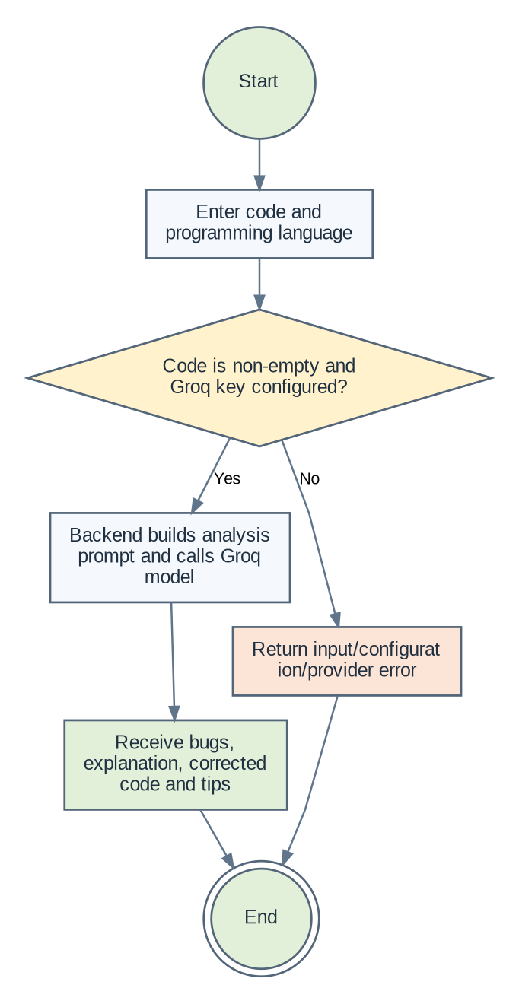
Figure 5.2.8: Scenario-7: AI Code Doctor Analysis

Scenario-8: Generate an AI Quiz
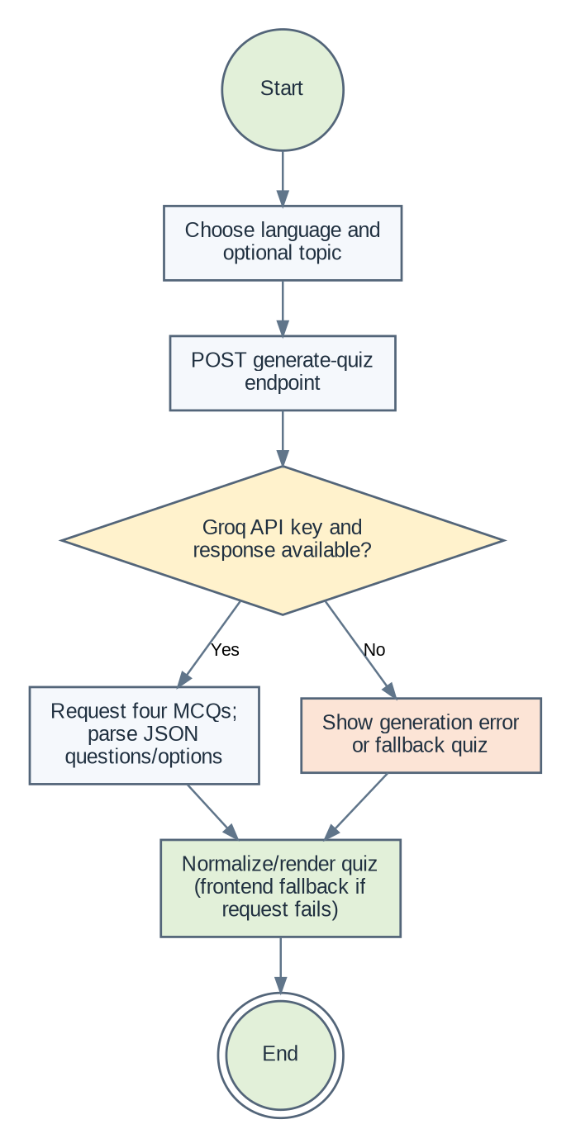
Figure 5.2.9: Scenario-8: Generate an AI Quiz

Scenario-9: Complete a Quiz and Record Learning XP
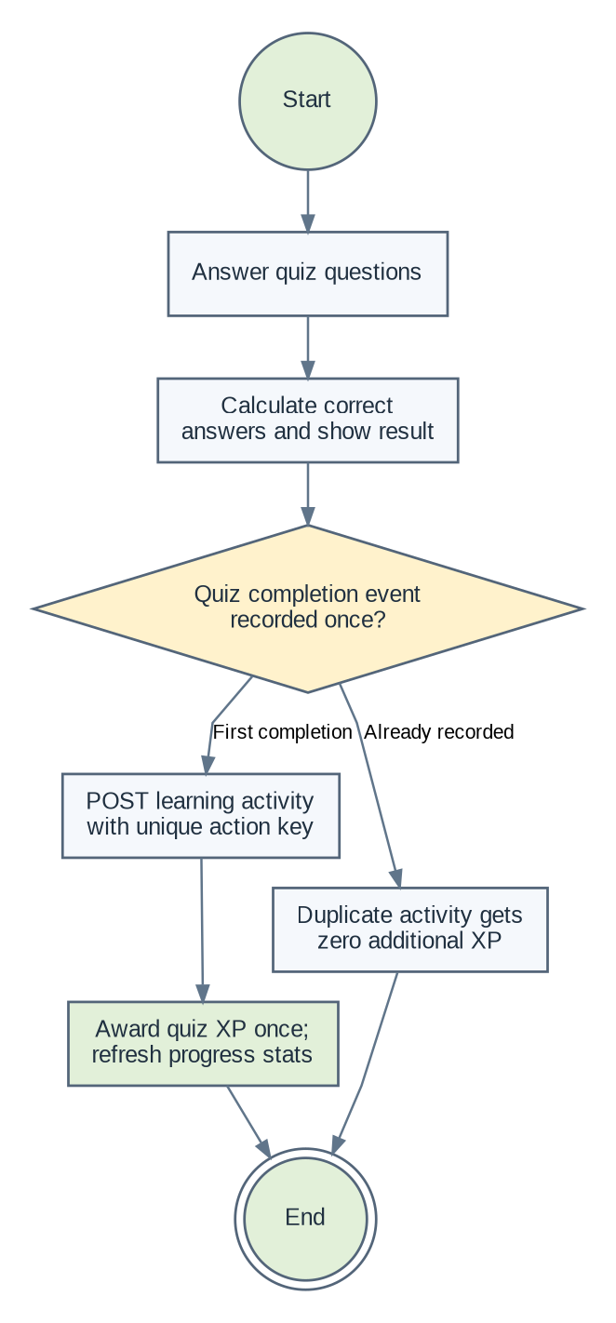
Figure 5.2.10: Scenario-9: Complete a Quiz and Record Learning XP

Scenario-10: Daily Challenge and Streak Tracking
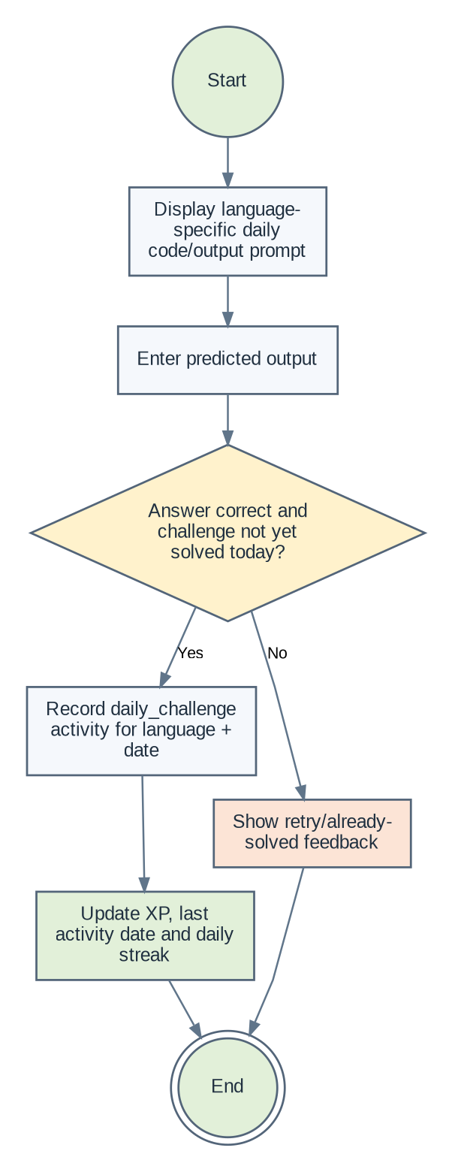
Figure 5.2.11: Scenario-10: Daily Challenge and Streak Tracking

Scenario-11: Solve a Bug-Fix Challenge
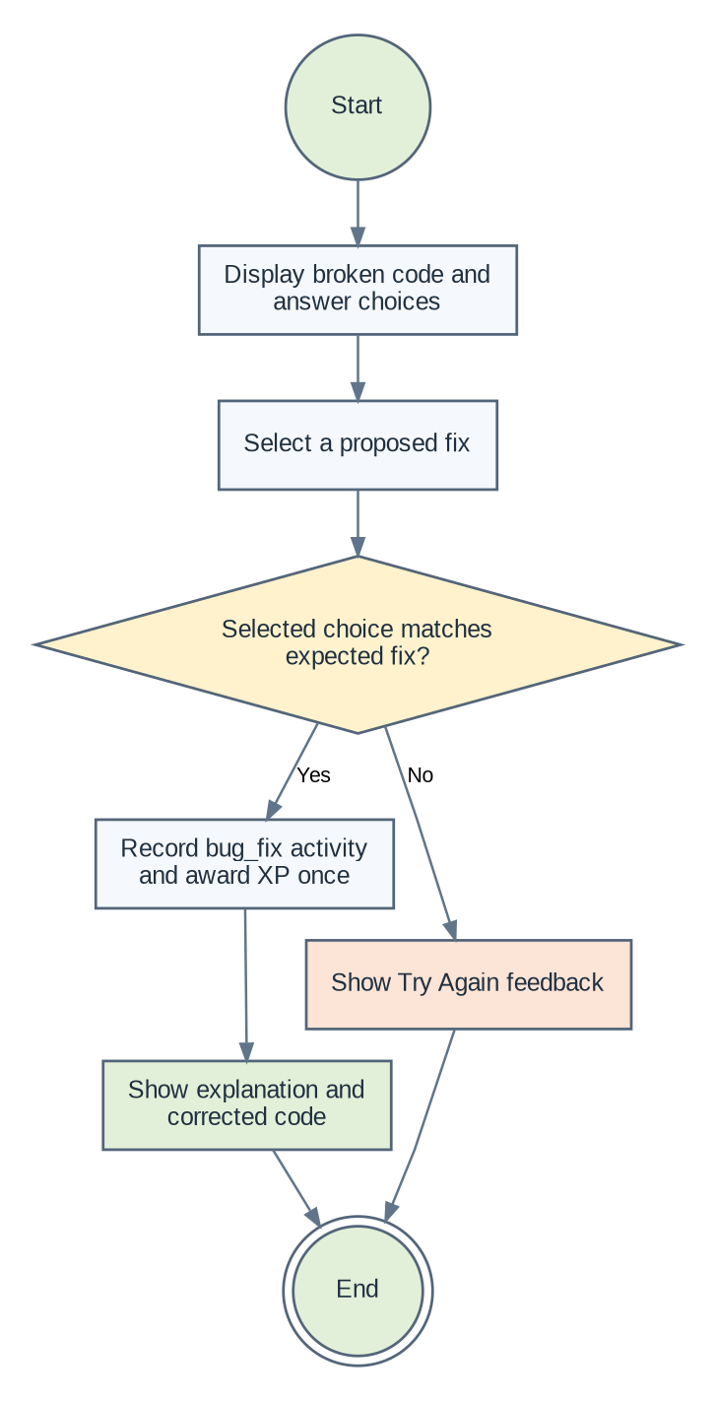
Figure 5.2.12: Scenario-11: Solve a Bug-Fix Challenge

Scenario-12: Create and Save Personal Language Notes
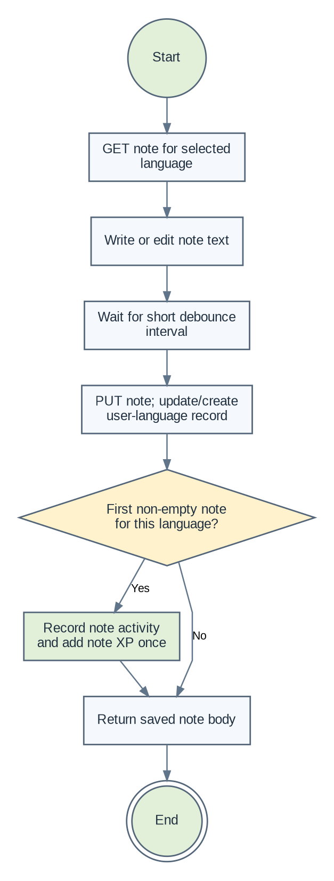
Figure 5.2.13: Scenario-12: Create and Save Personal Language Notes

Scenario-13: Mark Topic Completion and Review Learning Path
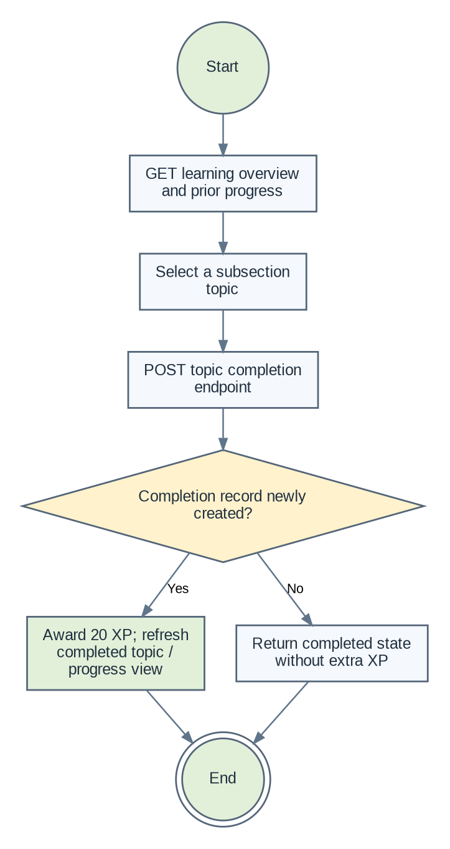
Figure 5.2.14: Scenario-13: Mark Topic Completion and Review Learning Path

Scenario-14: Browse Saved Content and Toggle Bookmarks
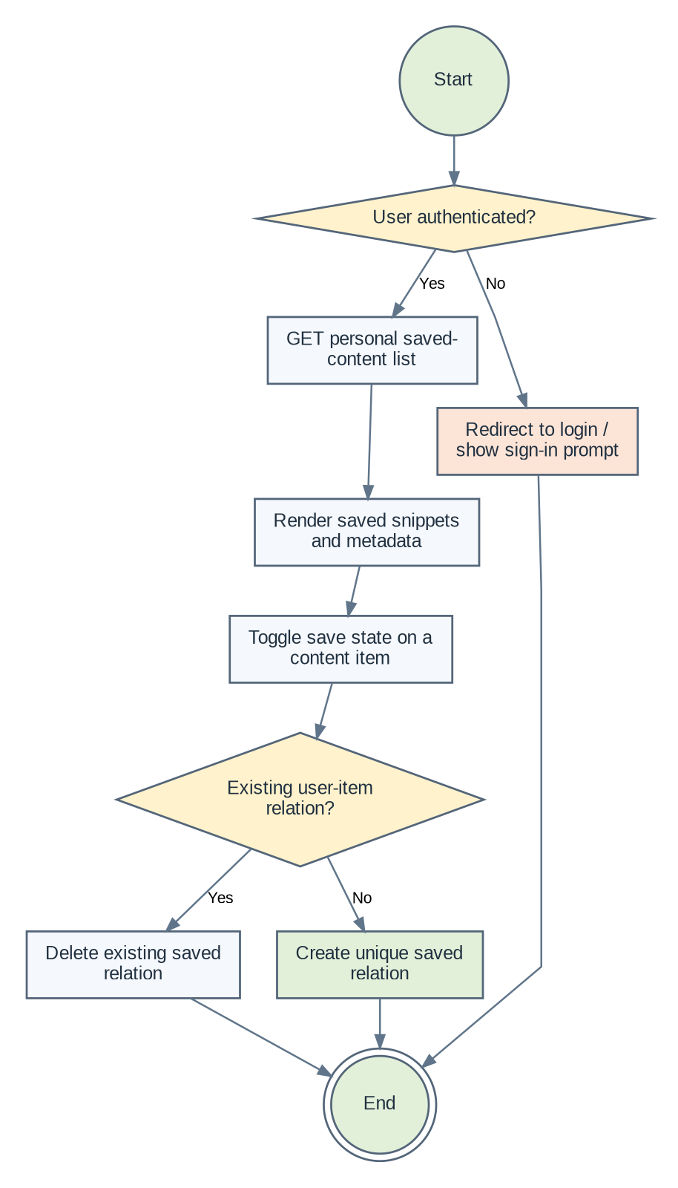
Figure 5.2.15: Scenario-14: Browse Saved Content and Toggle Bookmarks

Scenario-15: Administrator Dashboard, User List and Analytics
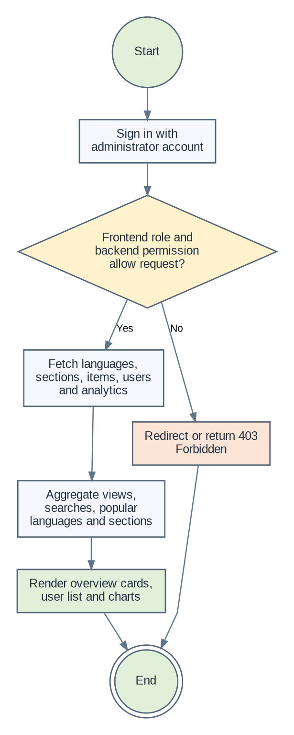
Figure 5.2.16: Scenario-15: Administrator Dashboard, User List and Analytics

Scenario-16: Manage Languages, Sections, Subsections and Content Items
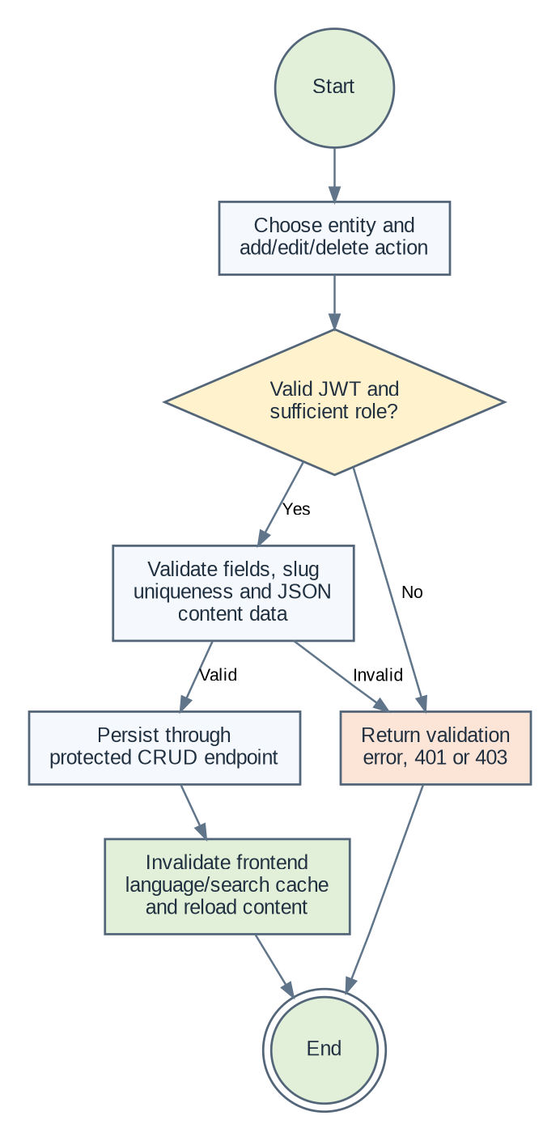
Figure 5.2.17: Scenario-16: Manage Languages, Sections, Subsections and Content Items

5.3 Database Design
The principal learning-content hierarchy is Language → Section → Subsection → ContentItem. User-centered learning records point to the same content tree to track notes, bookmarks, topic completions, last language, XP and streaks. Analytics and playground execution are represented by separate records. Most Django models inherit UUID identifiers and created/updated timestamps from BaseModel; a small number of operational models define similar fields explicitly.

Core Content Hierarchy ERD
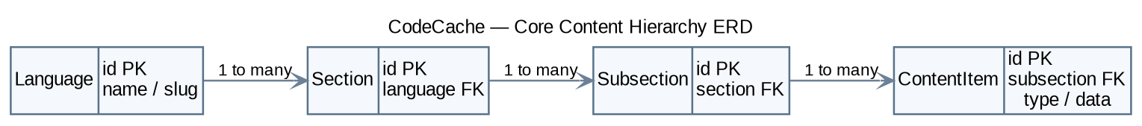
Figure 5.3: CodeCache Core Content Hierarchy Entity Relationship Diagram

Learning Progress Data Model
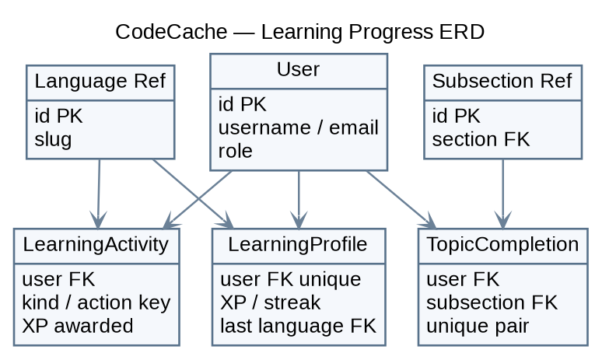
Figure 5.3.1: CodeCache Learning Progress Entity Relationship Diagram

Saved Content and Personal Notes Data Model
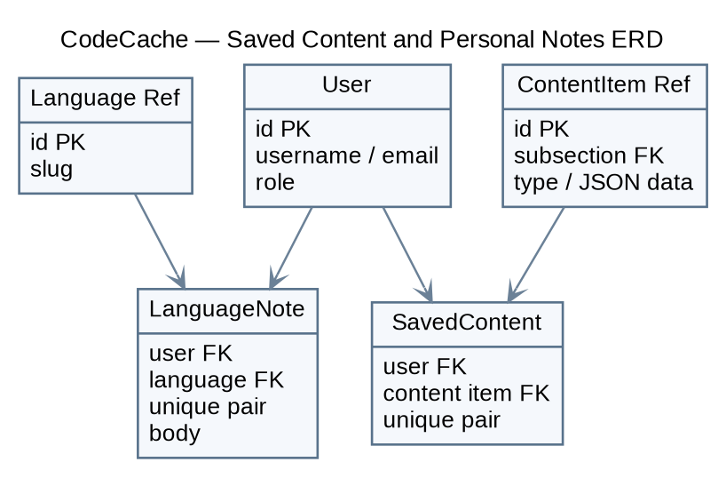
Figure 5.3.2: CodeCache Saved Content and Personal Notes Entity Relationship Diagram

Analytics and Playground Data Model
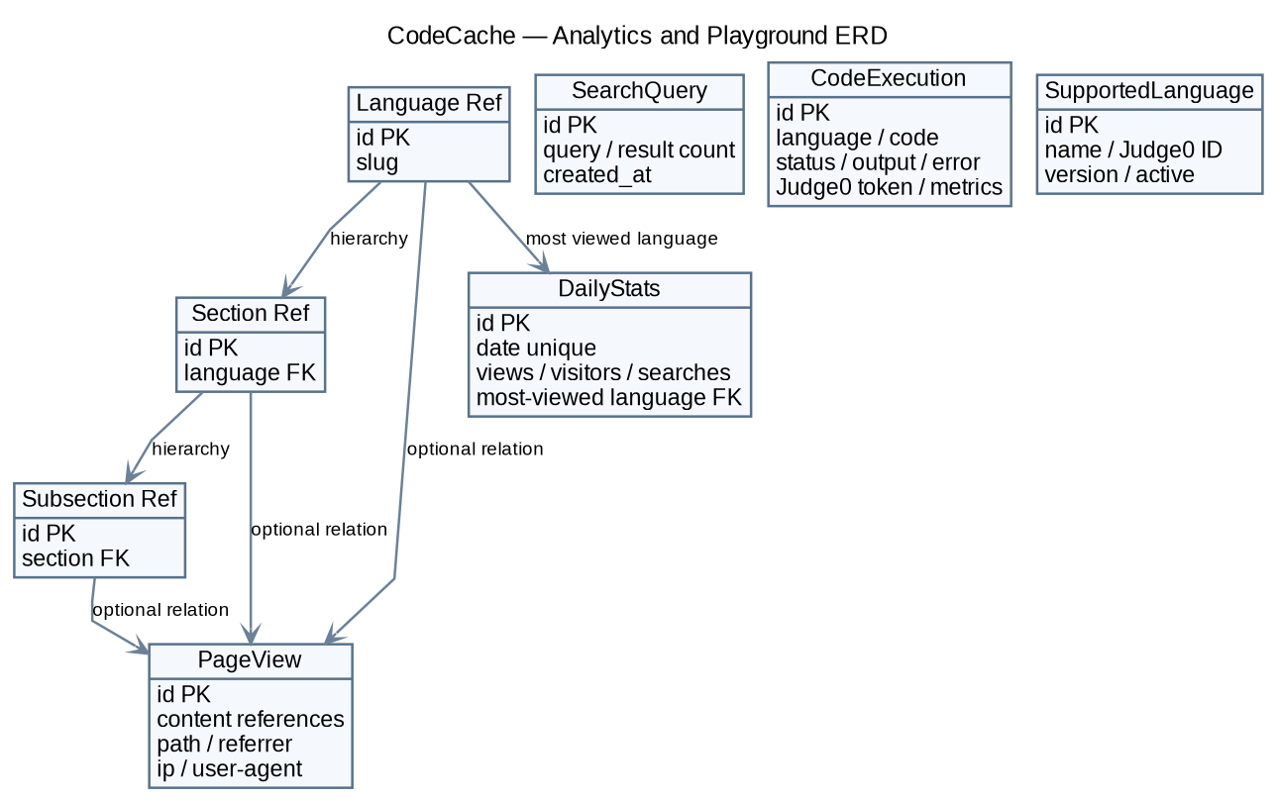
Figure 5.3.3: CodeCache Analytics and Playground Entity Relationship Diagram

Data Dictionary

User Table
Field Name | Data Type | Constraints | Description
id | UUID | PK; generated | Unique account identifier.
username | VARCHAR(50) | Unique; format validator | Public username.
email | EMAIL | Unique; USERNAME_FIELD | Login email.
password | VARCHAR | Not null; hashed by Django | Password hash, never returned to ordinary API clients.
first_name | VARCHAR(50) | Optional | First name.
last_name | VARCHAR(50) | Optional | Last name.
role | VARCHAR(20) | Default user; indexed | super_admin, admin, editor or user.
is_active | BOOLEAN | Default True | Account is allowed to authenticate.
is_staff | BOOLEAN | Default False | Django admin-site staff flag.
created_at / updated_at | TIMESTAMPTZ | BaseModel timestamps | Record creation and last update.

Language Table
Field Name | Data Type | Constraints | Description
id | UUID | PK | Language record identifier.
name | VARCHAR(100) | Unique | Display name, such as Python or JavaScript.
slug | VARCHAR(100) | Unique; lowercase slug validator | URL-friendly route identifier.
description | TEXT | Blank allowed | Short language description.
icon | ImageField | Optional; languages/icons/ | Django-managed icon path.
status | VARCHAR(20) | Default active; indexed | active, inactive, draft or archived.
display_order | POSITIVE INT | Default 0; indexed | Order in the language directory.
created_at / updated_at | TIMESTAMPTZ | BaseModel timestamps | Creation and update times.

Section Table
Field Name | Data Type | Constraints | Description
id | UUID | PK | Section identifier.
language_id | UUID FK | Language; CASCADE | Parent programming language.
title | VARCHAR(200) | Required | Section title.
slug | VARCHAR(200) | Unique per language | Section anchor/slug.
description | TEXT | Blank allowed | Section description.
display_order | POSITIVE INT | Default 0; indexed | Display order in a language.
status | VARCHAR(20) | Default active; indexed | Publication state.
created_at / updated_at | TIMESTAMPTZ | BaseModel timestamps | Lifecycle timestamps.

Subsection Table
Field Name | Data Type | Constraints | Description
id | UUID | PK | Subsection/topic identifier.
section_id | UUID FK | Section; CASCADE | Parent section.
title | VARCHAR(200) | Required | Topic title.
slug | VARCHAR(200) | Unique per section | Topic slug.
description | TEXT | Blank allowed | Topic summary.
display_order | POSITIVE INT | Default 0; indexed | Topic order.
status | VARCHAR(20) | Default active; indexed | Publication state.
created_at / updated_at | TIMESTAMPTZ | BaseModel timestamps | Lifecycle timestamps.

ContentItem Table
Field Name | Data Type | Constraints | Description
id | UUID | PK | Content block identifier.
subsection_id | UUID FK | Subsection; CASCADE | Parent topic.
type | VARCHAR(20) | ContentType choices | heading, paragraph, code, table, note, warning, tip, image, output, divider; enum also lists future types.
data | JSON | Object; defaults to {} | Type-specific data, e.g. text, code, title, columns or rows.
display_order | POSITIVE INT | Default 0; indexed | Order within a topic.
status | VARCHAR(20) | Default active; indexed | Publication state.
created_at / updated_at | TIMESTAMPTZ | BaseModel timestamps | Creation and update times.

LearningProfile Table
Field Name | Data Type | Constraints | Description
id | UUID | PK; BaseModel | Learning profile identifier.
user_id | UUID FK | OneToOne; CASCADE | One profile for each user.
xp | POSITIVE INT | Default 0 | Lifetime learning points.
current_streak | POSITIVE INT | Default 0 | Current daily challenge streak.
last_activity_date | DATE | Nullable | Date used for streak continuation.
last_language_id | UUID FK | Nullable; SET_NULL | Last selected language.

TopicCompletion Table
Field Name | Data Type | Constraints | Description
id | UUID | PK; BaseModel | Completion record identifier.
user_id | UUID FK | CASCADE; unique pair | Learner who completed the topic.
subsection_id | UUID FK | CASCADE; unique pair | Completed subsection.
created_at / updated_at | TIMESTAMPTZ | BaseModel timestamps | Record lifecycle.

SavedContent Table
Field Name | Data Type | Constraints | Description
id | UUID | PK; BaseModel | Saved relation identifier.
user_id | UUID FK | CASCADE; unique pair | User who saved the content.
content_item_id | UUID FK | CASCADE; unique pair | Saved content block.
created_at / updated_at | TIMESTAMPTZ | BaseModel timestamps | Record lifecycle.

LanguageNote Table
Field Name | Data Type | Constraints | Description
id | UUID | PK; BaseModel | Note record identifier.
user_id | UUID FK | CASCADE; unique pair | Note owner.
language_id | UUID FK | CASCADE; unique pair | Language the note is associated with.
body | TEXT | Blank allowed | Personal notes, memory hooks or reminders.
created_at / updated_at | TIMESTAMPTZ | BaseModel timestamps | Record lifecycle.

LearningActivity Table
Field Name | Data Type | Constraints | Description
id | UUID | PK; BaseModel | Activity record identifier.
user_id | UUID FK | CASCADE; unique triplet | User performing an activity.
language_id | UUID FK | Nullable; SET_NULL | Optional associated language.
kind | VARCHAR(30) | Required; unique triplet | daily_challenge, bug_fix, quiz or note.
action_key | VARCHAR(255) | Required; unique triplet | Key for avoiding repeat events.
xp_awarded | POSITIVE INT | Default 0 | XP granted by the activity.

CodeExecution Table
Field Name | Data Type | Constraints | Description
id | UUID | PK; BaseModel | Execution history identifier.
language | VARCHAR(50) | Required | Programming language label.
code | TEXT | Required | Source code submitted to Judge0.
output | TEXT | Blank allowed | Standard output.
error | TEXT | Blank allowed | Runtime or compiler error output.
execution_time | FLOAT | Nullable | Elapsed execution time, if returned.
memory_used | INTEGER | Nullable | Memory use in KB, if returned.
status | VARCHAR(20) | Default pending | Submission/execution state.
judge0_token | VARCHAR(100) | Blank allowed | External Judge0 token.

SupportedLanguage Table
Field Name | Data Type | Constraints | Description
id | UUID | PK; BaseModel | Supported-language record.
name | VARCHAR(50) | Unique | Language display name.
judge0_id | INTEGER | Unique | Judge0 numeric language identifier.
version | VARCHAR(50) | Blank allowed | Runtime version.
is_active | BOOLEAN | Default True | Availability flag.

PageView Table
Field Name | Data Type | Constraints | Description
id | UUID | PK; BaseModel | Page view event identifier.
language_id | UUID FK | Nullable; CASCADE | Language associated with the page.
section_id | UUID FK | Nullable; CASCADE | Section associated with the page.
subsection_id | UUID FK | Nullable; CASCADE | Subsection associated with the page.
path | VARCHAR(500) | Required | Visited route/path.
referrer | URL | Blank allowed | Referrer URL.
ip_address | IP ADDRESS | Nullable | Client IP as captured by the API.
user_agent | TEXT | Blank allowed | Browser/client identification string.
created_at / updated_at | TIMESTAMPTZ | BaseModel timestamps | Event timestamps.

SearchQuery Table
Field Name | Data Type | Constraints | Description
id | UUID | PK; BaseModel | Search event identifier.
query | VARCHAR(500) | Required | Search query text.
results_count | POSITIVE INT | Default 0 | Number of results observed by client.
ip_address | IP ADDRESS | Nullable | Client IP.
user_agent | TEXT | Blank allowed | Browser/client identity.
created_at / updated_at | TIMESTAMPTZ | BaseModel timestamps | Event timestamps.

DailyStats Table
Field Name | Data Type | Constraints | Description
id | UUID | PK; BaseModel | Daily aggregate identifier.
date | DATE | Unique | Date summarized.
total_views | POSITIVE INT | Default 0 | Number of recorded views.
unique_visitors | POSITIVE INT | Default 0 | Stored visitor aggregate; no scheduled updater was verified.
search_count | POSITIVE INT | Default 0 | Stored search aggregate.
most_viewed_language_id | UUID FK | Nullable; SET_NULL | Most viewed language for a day.

Database Integrity Rules
- Usernames and email addresses are unique; slugs for languages are unique and child slugs are unique within their parent scope.
- A Section belongs to a Language; a Subsection belongs to a Section; a ContentItem belongs to a Subsection. Configured CASCADE behavior removes dependent hierarchy records.
- A user can save a given content item only once and complete a given subsection only once.
- Language notes are unique per user and language; learning activities are unique per user/kind/action key.
- Public language detail serializes active sections, subsections and content items in display order.
- Content item data should be a JSON object and must match the keys expected by its frontend renderer.
- The Prisma schema is not a complete mirror of all current Django models; use Django migrations as the visible active ORM path unless the schema authority is deliberately changed.

6. Technical Implementation

6.1 Backend / Data Interaction Documentation

6.1.1 Backend Organization
The backend is a Django project with small feature applications. DRF views and serializers expose the REST API, custom permission classes enforce selected role boundaries, and PostgreSQL is configured through DATABASE_URL. The frontend calls the API through one Axios service module.
backend/
├── manage.py
├── config/
│ ├── urls.py # API routing, health/warmup and public AI views
│ └── settings/ # base, development, production
├── apps/
│ ├── accounts/ # custom User, auth serializers, JWT endpoints
│ ├── languages/ # language records and public/admin APIs
│ ├── content/ # Section, Subsection, ContentItem models and CRUD
│ ├── learning/ # XP, streaks, notes, saved items, topic completion
│ ├── search/ # content search and suggestions
│ ├── analytics/ # page views, queries and dashboard aggregations
│ ├── playground/ # Judge0 requests and execution history
│ └── common/ # permissions, constants, validation, pagination
├── utils/
│ ├── prisma_client.py # Prisma client helper (schema alignment required)
│ └── supabase_client.py # Supabase Storage helper functions
├── schema.prisma # parallel/partial database schema
└── requirements/ # base, development and production dependencies

6.1.2 RESTful API Endpoints
Module | HTTP Method | Endpoint | Purpose | Authentication
System | GET | / | Service health payload. | Public
System | GET | /warmup/ | Warm-up response. | Public
Accounts | POST | /api/v1/auth/register/ | Create user and return JWT pair. | Public
Accounts | POST | /api/v1/auth/login/ | Validate credentials and return JWT pair. | Public
Accounts | POST | /api/v1/auth/refresh/ | Return refreshed access token. | Refresh token
Accounts | GET / PATCH | /api/v1/auth/profile/ | Get/update permitted fields for current user. | JWT
Accounts | POST | /api/v1/auth/password-change/ | Change own password. | JWT
Accounts | POST | /api/v1/auth/logout/ | Blacklist submitted refresh token. | JWT
Accounts | GET | /api/v1/auth/users/ | List users if admin role check passes. | Admin role
Languages | GET | /api/v1/languages/ | List active programming languages. | Public
Languages | GET | /api/v1/languages/{slug}/ | Fetch active language plus nested reference tree. | Public
Admin content | GET / POST | /api/v1/admin/languages/ | List all / create languages. | Admin
Admin content | PUT / DELETE | /api/v1/admin/languages/{id}/ | Update or delete a language. | Admin
Admin content | GET / POST | /api/v1/admin/sections/ | List / create sections. | Admin
Admin content | PUT / DELETE | /api/v1/admin/sections/{id}/ | Update or delete section. | Admin
Admin content | GET / POST | /api/v1/admin/subsections/ | List / create subsections. | Editor/Admin by backend role
Admin content | PUT / DELETE | /api/v1/admin/subsections/{id}/ | Update or delete subsection. | Editor/Admin by backend role
Admin content | GET / POST | /api/v1/admin/content-items/ | List / create content blocks. | Admin
Admin content | PUT / DELETE | /api/v1/admin/content-items/{id}/ | Update or delete content block. | Admin
Search | GET | /api/v1/search/?q={query} | Search active language hierarchy and items. | Public
Search | GET | /api/v1/search/suggestions/?q={query} | Return suggestions for language/section/topic. | Public
Playground | GET | /api/v1/playground/languages/ | Return unique supported Judge0 languages. | Public
Playground | POST | /api/v1/playground/run/ | Submit code and optional stdin to Judge0. | Public
Playground | GET | /api/v1/playground/status/{token}/ | Fetch execution history by external token. | Public
AI | POST | /api/v1/ai/code-doctor/ | Analyze code through Groq. | Public; GROQ_API_KEY required
AI | POST | /api/v1/ai/generate-quiz/ | Generate four MCQs through Groq. | Public; GROQ_API_KEY required
Learning | GET | /api/v1/learning/overview/ | Return XP, streak, saved and completed IDs. | JWT
Learning | POST | /api/v1/learning/topics/{uuid}/complete/ | Mark subsection completed; award first-completion XP. | JWT
Learning | GET / POST | /api/v1/learning/saved/ | List saved content / toggle a bookmark. | JWT
Learning | GET / PUT | /api/v1/learning/notes/{language_slug}/ | Read/write note for a language. | JWT
Learning | POST | /api/v1/learning/activities/ | Record configured activity and XP. | JWT
Learning | PUT | /api/v1/learning/last-language/ | Set last selected language. | JWT
Analytics | POST | /api/v1/analytics/view/ | Track a route and optional content hierarchy. | Public
Analytics | POST | /api/v1/analytics/search/ | Record non-empty search and result count. | Public
Analytics | GET | /api/v1/analytics/popular/ | Return top languages/sections for 7 days. | Public
Analytics | GET | /api/v1/analytics/ | Admin usage overview and trends. | Admin

6.1.3 External Services and Media Handling
Groq AI: The code doctor and quiz-generation functions are defined in the project URL configuration and call Groq using GROQ_API_KEY and GROQ_MODEL. The source code and selected language/topic are sent to the provider. These endpoints are public in the checked-in routing; production should add request limits, input-size limits, monitoring, and vendor usage controls.
Judge0: The playground maps language labels to Judge0 IDs, encodes source and stdin, submits to the configured Judge0 endpoint, then decodes stdout, stderr and compile output. The actual code execution is external to the Django process. Timeout, quota and provider behavior must be treated as dependencies, not as an internally guaranteed runtime.
Supabase Storage: `backend/utils/supabase_client.py` provides client initialization, path generation, upload, deletion and public URL helpers for the `codecache-media` bucket. The Language model also declares an ImageField. The ordinary language/content API views reviewed do not visibly call the storage helper, so production media upload, deletion consistency and permissions require end-to-end verification before claiming full media persistence.

6.1.4 Search Implementation
The full search endpoint uses Django ORM `icontains` matching over active languages, sections, subsections and content JSON. Queries must contain at least two characters; up to 50 results per content category can be returned, in both flat and grouped structures. Suggestions are a separate endpoint that searches language, section and subsection names. This is straightforward database text matching, not a relevance-ranked search engine or PostgreSQL full-text search index.

6.1.5 Learning Progress, XP and Client Cache
Activity / Feature | Behavior defined in source
Topic completion | First creation of a User + Subsection completion awards 20 XP; later requests return completed without another award.
Daily challenge | 90 XP per unique activity event; uses the last activity date to continue or reset streak.
Bug-fix challenge | 60 XP per unique correct challenge action key; challenge content is local frontend data.
Quiz | 75 XP per unique quiz action key; duplicate event keys do not increase XP.
Notes | 15 XP configured for first non-empty note creation; note records are unique per user/language.
Saved content | A single unique relation per user/content item; request toggles add/remove.
Client cache | Memory Map plus sessionStorage, five-minute default time-to-live, stale revalidation, and language/search cache invalidation after admin mutations.

6.1.6 Admin Control and Analytics
The custom administrator dashboard loads language and content datasets, user records and analytics summaries. Management screens create, update and delete language, section, subsection and content-item records via API calls; relevant client caches are invalidated after mutations. The analytics dashboard includes today/yesterday page views, percentage change, approximate unique visitors by distinct IP, daily view trends, top languages and sections, top searches, and 30-day totals. Public endpoints accept tracking events; sensitive deployment environments should review retention and privacy notice requirements for IP and user-agent logging.
Administrative boundary note: User listing is read-only in the custom API and the repository dashboard does not demonstrate banning, account suspension, post moderation or audit-log workflows. Those controls should not be described as implemented.

6.2 Relationship & Access Rules
Role / State | Allowed capabilities in the reviewed implementation | Restricted / caveat
Unauthenticated Visitor | Browse active content, search, view popular content, submit code to Judge0, call AI endpoints, send analytics events. | Cannot access JWT-protected learning endpoints or admin-only content mutations.
Registered User | Profile and password operations; saved content; notes; topic completion; XP/streak activities; selected-language preference. | Cannot access administrator CRUD or analytics dashboard. Authenticated user list additionally checks admin role.
Editor | Backend IsEditor permits selected subsection operations; IsEditor also describes section/content-management capability in its docstring. | Language/section/content endpoints vary and many use IsAdmin; frontend admin route only permits admin/super_admin.
Administrator | Language, section and content-item CRUD; analytics dashboard; registered-user list. Subsection CRUD passes IsEditor. | Custom dashboard does not implement user bans, content moderation queues or audit-log views.
Super Administrator | Same custom admin API family, plus Django superuser/staff behavior where configured. | Server-side permissions still apply to DRF endpoints; deployment secrets and database admin access must remain restricted.

6.3 Frontend Organization
The React single-page application uses React Router for navigation, lazy-loaded route components for larger pages, shared UI components and a central Axios layer for API and token handling.
frontend/
├── src/
│ ├── App.jsx # route table, auth context and route guards
│ ├── pages/
│ │ ├── Home.jsx # language landing page and search entry
│ │ ├── LanguagePage.jsx # nested content reader and learning tools
│ │ ├── SearchResults.jsx # search results and analytics tracking
│ │ ├── SavedItems.jsx # user bookmarks
│ │ ├── LearningPath.jsx # progress dashboard and topic navigation
│ │ ├── AdminLogin.jsx # login form for user/admin routes
│ │ └── AdminDashboard.jsx # content-management and analytics UI
│ ├── components/ # snippets, AI doctor, quiz, challenges, notes
│ ├── services/
│ │ ├── api.js # Axios, JWT refresh and feature APIs
│ │ └── cache.js # memory + sessionStorage cache
│ ├── lib/ # language styles, learning seeds and utilities
│ ├── main.jsx # React entry point
│ └── index.css # global/theme styles
├── package.json
├── vite.config.js
└── tailwind.config.js

6.4 Administration Frontend Organization
`AdminDashboard.jsx` provides an overview and data-management screens. `AdminLayout.jsx` and `AdminLogin.jsx` provide the protected layout/login flow, while `pages/admin/adminConfig.js` defines content types and form defaults. The dashboard uses `adminAPI` functions in `services/api.js` to list, create, update and delete content and fetch analytics/user records. The server is authoritative for permissions; hiding a route is not security by itself.
- Content type forms currently cover heading, paragraph, code, table, note, warning, tip, output, divider and image blocks.
- Frontend auth context identifies admin users by role values admin or super_admin. Backend endpoint permissions are slightly broader/narrower depending on IsAdmin versus IsEditor; align role policy and UI before expanding editor management.
- The built-in Django admin registers User, Language, Section, Subsection and ContentItem models. It is separate from the custom React dashboard and follows Django staff/superuser permissions.

7. Quality Assurance & Testing

7.1 Test Case Scenarios
The repository snapshot contains no dedicated comprehensive test suite for the listed end-to-end scenarios. The following cases define the expected verification plan; their status is Planned, not a claim that they have been executed or passed.
Test ID | Description | Input / Conditions | Expected Result | Status
TC-01 | Valid registration | Unique username/email and matching valid passwords | Account created and access/refresh JWTs returned. | Planned
TC-02 | Duplicate account | Reuse existing username or email | Validation fails without duplicate account. | Planned
TC-03 | Password mismatch | Different password/password_confirm | Registration returns validation error. | Planned
TC-04 | Invalid login | Incorrect email/password | Authentication rejected; no tokens issued. | Planned
TC-05 | Access refresh | Expired access + valid refresh | New access token returned and request retry succeeds. | Planned
TC-06 | Profile access | Authenticated request to profile | Current user profile fields returned. | Planned
TC-07 | Profile ownership | Attempt to patch role or username | Read-only fields remain unchanged/rejected. | Planned
TC-08 | Password change | Valid current/new password input per serializer | Password updated; new credentials work. | Planned
TC-09 | Public language list | Request language list | Only active languages returned in display order. | Planned
TC-10 | Language detail | Known active slug | Nested active section/topic/content tree returned. | Planned
TC-11 | Missing language | Unknown or inactive slug | 404 with language-not-found response. | Planned
TC-12 | Slug uniqueness | Duplicate child slug within parent | Serializer validation rejects duplicate. | Planned
TC-13 | Search minimum length | Query shorter than 2 characters | 400 response with validation message. | Planned
TC-14 | Search hierarchy | Query term appears in language and content data | Flat and grouped matching results returned. | Planned
TC-15 | Search suggestions | Prefix matching language/topic | Suggestions returned, capped to configured count. | Planned
TC-16 | Copy snippet | Click Copy on displayed code | Current editable code reaches clipboard. | Planned
TC-17 | Save snippet | Authenticated user toggles save twice | First creates relation; second removes it. | Planned
TC-18 | Saved uniqueness | Repeat same save relation request pattern | Only one user/content relation persists. | Planned
TC-19 | Run supported code | Valid language, code and stdin | Judge0 response returns output/status; execution record saved. | Planned
TC-20 | Unsupported runner language | Unknown language label | 400 response; no successful execution reported. | Planned
TC-21 | Judge0 failure | Provider timeout or non-201 result | Execution marked failed and structured error returned. | Planned
TC-22 | AI Code Doctor missing key | GROQ_API_KEY absent | API returns a configuration error. | Planned
TC-23 | AI Code Doctor normal flow | Non-empty code and valid provider config | Analysis result returned with language. | Planned
TC-24 | AI Quiz output | Provider returns valid JSON question payload | Four questions/options render as expected. | Planned
TC-25 | AI Quiz provider failure | No key, invalid JSON or request failure | Failure handled; frontend fallback behavior verified. | Planned
TC-26 | Topic completion | First completion by user | Topic marked complete and 20 XP awarded. | Planned
TC-27 | Duplicate topic completion | Complete same subsection again | No duplicate completion; no additional XP. | Planned
TC-28 | Learning activity idempotency | Repeat same kind/action_key | Only first record awards configured XP. | Planned
TC-29 | Daily streak | Complete on consecutive versus missed dates | Streak continues on consecutive dates; resets after a gap. | Planned
TC-30 | Language notes | GET then PUT note for one language | Note is private to user and persisted to user/language row. | Planned
TC-31 | Admin role boundary | Regular user calls admin languages endpoint | 403/permission denial and no data mutation. | Planned
TC-32 | Editor role mismatch | Editor opens custom admin page and subsection endpoint | Observed behavior documented; policy aligned to intended access. | Planned
TC-33 | Admin language CRUD | Valid create/update/delete language calls | Data changes persist and client cache invalidates. | Planned
TC-34 | Admin content CRUD | Create typed content with JSON object | Valid block persists; malformed non-object data rejected. | Planned
TC-35 | Analytics tracking | Post page view and search events | Event rows created; empty search tracking rejected. | Planned
TC-36 | Analytics admin access | Normal user requests analytics dashboard | 403/permission denied; admin can read aggregate response. | Planned
TC-37 | CORS production | Production origin not allow-listed | Request from unapproved origin denied after hardening. | Planned
TC-38 | Media integration | Upload/remove configured image through deployed flow | File and DB path remain consistent; helper wiring verified. | Planned
TC-39 | Responsive layout | Mobile and desktop viewport widths | Content, topic index and dialogs remain usable. | Planned
TC-40 | ORM/schema reconciliation | Run documented migrations on clean test DB | Django migration result and Prisma schema mismatch documented/resolved. | Planned

7.2 Requirements Traceability Matrix (RTM)
FR / NFR ID | Feature | Test IDs | Coverage / Verification Focus | Status
FR01–FR05 | Auth and profile | TC-01–TC-08 | Account validation, JWT lifecycle, profile/password checks. | Planned
FR06–FR08 | Reference hierarchy and renderer | TC-09–TC-12, TC-34 | Active hierarchy, status filtering, typed JSON content. | Planned
FR09–FR10 | Snippet actions and saving | TC-16–TC-18 | Copy/edit UI and saved relation behavior. | Planned
FR11–FR15 | Learning progression | TC-26–TC-30 | Topic completion, XP, streak, notes, preferences. | Planned
FR16–FR17 | Search | TC-13–TC-15 | Query validation, matching and suggestions. | Planned
FR18–FR19 | Playground | TC-19–TC-21 | Language map, Judge0 call, failure paths. | Planned
FR20–FR21 | AI learning services | TC-22–TC-25 | Groq configuration and valid/fallback payload. | Planned
FR22–FR25 | Analytics | TC-35–TC-36 | Event capture, public popular data and admin boundary. | Planned
FR26–FR30 | Administration | TC-31–TC-34 | Role checks, CRUD and validation. | Planned
FR31–FR32 | Caching and responsive UI | TC-16, TC-33, TC-39 | Cache invalidation and layout behavior. | Planned
NFR Security / consistency | Production readiness | TC-37, TC-38, TC-40 | CORS hardening, media and schema validation. | Planned

8. Individual Contribution
The repository is maintained under the GitHub account ShoaibSikder and the README links the project to the maintainer portfolio. A source-code review can describe the project areas represented in the repository, but it cannot establish individual effort percentages, design ownership, or contributions from collaborators. No unsupported percentage allocation is included here.
- Frontend implementation: routing, responsive learning pages, typed code content rendering, snippet cards, AI/quiz/challenge components, saved-items and learning-path screens.
- Backend implementation: Django app structure, custom user model and JWT endpoints, content hierarchy, search, learning progress, analytics and playground integration.
- Integration/configuration: Groq AI requests, Judge0 execution requests, Supabase PostgreSQL setup, optional Supabase Storage helper, client cache and environment-driven deployment settings.
- Administration and documentation: custom dashboard workflows, role-aware API design, setup instructions and repository maintenance.
Contribution statement: These are functional areas present in the reviewed repository, not a verified time-sheet or a claim that every planned integration has been deployed.

9. Conclusion & Future Work
CodeCache brings programming-reference content, code interaction, AI assistance and learner progress into a single full-stack application. Its hierarchical content model and feature-separated backend apps provide a sound base for expanding language guides and learning tools. The main development priorities are operational consistency and verification: align the database schema/migration workflow, confirm external-service integration in a deployed environment, strengthen production controls, and add automated tests around authentication, permissions, progress rules and provider failures.

Recommended Future Work
- Reconcile Prisma and Django models/migrations, identify one authoritative schema, and revise README commands so a fresh database can be provisioned reproducibly.
- Connect Supabase Storage upload/delete helpers to the administrative content workflow (or document a deliberate alternative), validate image type/size, and handle orphaned storage objects.
- Set CORS_ALLOW_ALL_ORIGINS=False in production, configure exact allowed origins, verify ALLOWED_HOSTS and proxy/HTTPS settings, and manage secrets outside source control.
- Add rate limiting and request/code-size limits for public Groq and Judge0 endpoints; avoid returning raw provider exception details to untrusted clients.
- Add backend tests for role access and all unique constraints, API integration tests for external-service failure cases, and frontend tests for fallback/error states.
- Implement or remove future content block types that the frontend renderer currently does not support: quiz, mcq, roadmap, video and download.
- Replace static Community Solutions cards with a real data model/API if collaborative community contributions are an intended product feature.
- Create and schedule an analytics aggregation pipeline if DailyStats is meant to be maintained; currently the reviewed dashboard calculates many statistics directly from PageView and SearchQuery.
- Review JWT storage and analytics retention for the production threat model and privacy policy; consider secure HttpOnly cookie architecture if compatible with the app design.
- Align backend role policy, frontend route guards, and the Django admin model so editor/admin/super-admin capabilities are easy to reason about.

10. Appendices

Appendix A: Repository and Architecture Notes
The canonical source reviewed for this document is the public main branch of CodeCache. Repository tree and README were inspected along with the principal Django models, serializers, views, URL mappings, permissions, settings, Prisma schema, storage helper, and React route/service/components. Repository review date: October 24, 2026.
- Primary content path: Language → Section → Subsection → ContentItem, with JSON-backed content types and active/draft/inactive/archived state.
- Authentication path: Django custom User + Simple JWT access/refresh token endpoints; frontend requests use a Bearer access token stored in localStorage.
- Data path: current operational endpoints use Django ORM and configured PostgreSQL; the checked-in Prisma model is a partial parallel schema rather than evidence that all API operations use Prisma.
- External runtime: Groq handles AI review/quizzes, while Judge0 handles execution; both require correct network settings/provider credentials and may have quotas.

Appendix B: Backend Setup
Prerequisites: Python compatible with the Django dependency range, PostgreSQL/Supabase database credentials, Node.js for the frontend, and API keys for Groq and Judge0 if those features are to be used.
git clone https://github.com/ShoaibSikder/CodeCache.git
cd CodeCache/backend
python -m venv venv
# Windows PowerShell: .\venv\Scripts\Activate.ps1
# macOS/Linux: source venv/bin/activate
pip install -r requirements/base.txt
# Create .env from .env.example and populate every required secret/URL.
python manage.py migrate
python manage.py createsuperuser
python manage.py runserver
Schema warning: README also lists `prisma generate` and `prisma migrate dev --name init`. Do not run the Prisma migrations alongside Django migrations on a fresh/production database until the schema mismatch has been reconciled and the intended source of truth is explicitly selected.

Appendix C: Frontend Setup and Deployment
cd CodeCache/frontend
npm install
# Create .env.local and set: VITE_API_URL=http://localhost:8000
npm run dev
# Production bundle
npm run build
npm run preview
The README suggests deploying the Vite `dist/` build to Vercel and deploying the Django backend to Render with Gunicorn (for example, `gunicorn config.wsgi:application`). Configure the frontend VITE_API_URL to the deployed API, populate backend environment variables in the hosting service, run Django migrations intentionally, and verify API/CORS/HTTPS/Judge0/Groq behavior after deployment.

Appendix D: Environment Variables
Variable | Component | Purpose | Configuration Notes
SECRET_KEY | Backend | Required secret key for Django signing and JWT signing. | Never commit the actual secret.
DEBUG | Backend | Development debug setting; production settings force DEBUG=False. | Must remain False in production.
ALLOWED_HOSTS | Backend | Comma-separated host names accepted by Django production settings. | Set exact API host(s).
DATABASE_URL | Backend / Prisma | PostgreSQL connection string. Django base settings require it and set sslmode=require. | Use the provider’s recommended pooler/connection settings.
SUPABASE_URL | Backend storage helper | Project URL used by Supabase client/public URL assembly. | Required for Storage helper operations.
SUPABASE_SERVICE_KEY | Backend storage helper | Service key used for Storage API operations. | Keep only on backend; never expose to Vite.
SUPABASE_BUCKET | Backend storage helper | Bucket name; defaults to codecache-media. | Create bucket and set access policy deliberately.
GROQ_API_KEY | Backend AI | API credential for code review and quiz generation. | Restrict access and monitor usage.
GROQ_MODEL | Backend AI | Model identifier; default llama-3.3-70b-versatile. | Confirm availability with provider account.
JUDGE0_API_URL | Backend playground | Judge0 base endpoint, default rapidapi CE endpoint. | Use trusted provider base URL.
JUDGE0_API_KEY | Backend playground | Optional configured RapidAPI key. | Avoid empty key in production where required.
JUDGE0_API_HOST | Backend playground | RapidAPI host header; defaults to judge0-ce.p.rapidapi.com. | Match the selected endpoint/provider.
FRONTEND_URL / CORS_ALLOWED_ORIGINS | Backend deployment | Intended frontend URL/origin configuration. | Verify settings actually consume the variable and disable permissive CORS.
VITE_API_URL | Frontend build | Base URL of the deployed API; defaults to localhost:8000. | Frontend-prefixed vars are public build-time values; no secrets belong here.

Appendix E: Administrator Setup and Responsibilities
- Create a privileged account using Django createsuperuser or the approved account-provisioning process; assign application roles intentionally.
- Use the custom dashboard to review content and analytics; use Django admin only for registered models and when staff/superuser access is appropriate.
- Before making large deletions, confirm parent-child cascade behavior because deleting a language/section can remove dependent lesson content.
- Keep service credentials and database URLs in the hosting provider’s secret manager/environment configuration.
- Review page-view/search logs for privacy implications and keep retention proportional to the analytics purpose.
- Confirm exact role behavior on the API, especially editor versus admin access, before granting operational accounts.

Appendix F: Limitations and Verification Notes
Area | Finding / Recommendation
Database authority | The README and schema.prisma describe Prisma, but active API models/views and Django migrations are implemented with Django ORM; the Prisma schema is incomplete/different. Choose and validate one authoritative migration path.
Storage wiring | Supabase Storage functions exist, but the normal content API does not visibly call them. The Language icon is a Django ImageField. End-to-end uploads, public/private access and delete consistency need verification.
Production CORS | Base settings set CORS_ALLOW_ALL_ORIGINS=True. Production settings configure allowed origins but do not visibly override that permissive boolean. Explicitly set False and test the deployed origin list.
Role consistency | Subsection endpoints use IsEditor, other content endpoints use IsAdmin, and frontend dashboard route guard admits admin/super_admin. Intended role design should be harmonized.
Content block coverage | Enums contain future types quiz, mcq, roadmap, video and download; the reviewed LanguagePage renderer has no case handlers for those types.
Community Solutions and visual lab | CommunitySolutions currently renders fixed example cards rather than API-backed user submissions/voting. VisualLearningLab is a client-side variable visualization, not remote code execution.
Test status | No comprehensive automated test suite was visible in the repository tree reviewed. All test cases in Section 7 are planned verification, not pass results.
External-service protection | The reviewed AI and playground endpoints are public. Production should add throttling, request-size/input guardrails, safe error reporting and budget/abuse monitoring.
Analytics aggregation | Dashboard analytics calculate several metrics directly from raw event rows; although DailyStats exists, no scheduled updater was verified in the inspected source.
Deployment verification | No credentials or live cloud database were tested during document generation. Host config, CORS, schema migrations, media, and external provider behavior must be verified in the actual deployment.

Appendix G: Repository References
Repository: https://github.com/ShoaibSikder/CodeCache
- README.md — product summary, stack, declared endpoints and setup/deployment instructions.
- backend/config/urls.py and backend/config/settings/ — route wiring, AI endpoints and environment/security configuration.
- backend/apps/accounts, backend/apps/languages, backend/apps/content — authentication, language data and nested reference content.
- backend/apps/learning, backend/apps/search, backend/apps/analytics, backend/apps/playground — learning records, search, analytics and Judge0 execution.
- backend/apps/common/constants.py, permissions.py, validators.py and pagination.py — roles, content types, state, validation and pagination.
- backend/schema.prisma and backend/utils/ — parallel Prisma schema/client and Supabase Storage helper functions.
- frontend/src/App.jsx, frontend/src/pages, frontend/src/components and frontend/src/services — UI routes, workflow components, API calls and cache behavior.
End of CodeCache Project Documentation

